Exweb – Exchange Services

Technical Solution Recommendation

Version 1.0
14th September 2007

For Circulation to:

Kevin Budge  Chris Butler  David Child | Howard Goodman  Paul Yates

© Exchange FS Limited 2007
The contents of this report are the copyright of Exchange FS Ltd (trading as The Exchange) and all rights reserved. No part of this document may be reproduced, stored in a retrieval system or transmitted, in any form or by any means electronic, mechanical, recording or otherwise, without the prior written consent of the copyright owner.

Document control and record of amendments
Version | Reason for amendment | Sections amended | Amended by/date | Reviewed by/date
0.1 | New document | All | Martin Brewster Jonathan Whiteside 06/09/2007 | Chris Butler Mark Coleman Allan Davies John Tonks
0.2 | Updated following review | All | Martin Brewster Jonathan Whiteside 13/09/2007 | Chris Butler Mark Coleman Allan Davies John Tonks
0.3 | Updated following review | 1, 3.3, 5.1, 5.3, 5.4, 6.1, 6.2 & 6.3 | Jonathan Whiteside 14/09/2007 | Chris Butler
1.0 | Tracking accepted |  | Jonathan Whiteside 14/09/2007

Change Forecast
Change | Reference | Description

Contents
1. Executive Summary 4
2. Introduction 6
2.1 Purpose of the Document 6
2.2 Exchange Services in Context 6
2.3 Scope of Exchange Services 6
2.4 Assumptions 7
3. Why BizTalk? 8
3.1 What is BizTalk? 8
3.2 Previous Encounters 8
3.2.1 BizTalk Server 2000 8
3.2.2 BizTalk Server 2002 8
3.2.3 BizTalk Server 2004 8
3.3 Proof of Concept 9
4. Benefits 10
5. Indicative Costs 11
5.1 External Consultancy 11
5.2 External Training 11
5.3 Hardware 11
5.3.1 Cost Assumptions 11
5.3.2 Hardware Cost Summary 11
5.4 Software Licences 12
5.4.1 Licences Required 12
5.4.2 Cost Assumptions 12
5.4.3 Licence Cost Summary 12
6. Comparative Costs – Build vs Buy 12
6.1 Build Estimates 13
6.2 Assumptions 13
6.3 Breakdown by Year 13
6.4 Build vs Buy Graph 14
7. Next Steps 15

Executive Summary
The SETP programme is delivering a new architecture for the Exchange which creates a discrete business services hub – "Exchange Services".
A technical framework is required for Exchange Services that provides the common messaging and communication services ("the plumbing") required by any business service.
BizTalk is the Microsoft enterprise offering in this space and is the only alternative to a completely bespoke Exchange development.
A series of workshops with Microsoft, culminating in a week-long laboratory prototype of a Term Comparison Quotation, including translation of message formats to Origo standards, have provided confidence that the product is technically viable, can provide the performance required by existing Exchange services and has the scalability required to support future Exchange growth.

Recommendation
Microsoft BizTalk Server 2006 R2 is recommended as the way forward to provide the Exchange Services technical framework.

Key Benefits
- Supports bringing Exchange Services to market by the end of 2008
- Suitable for both UK and non-UK implementations with a common messaging framework
- Fits with Vertex corporate strategy for enterprise-scale solutions
- Supports P4F programme with Microsoft Dynamics and SharePoint integration opportunities
- Is a good fit for Exchange architecture and technology roadmaps
- Offers potential for complete Exchange Business Activity Monitoring and MI capture
- Delivers significant message framework capability out of the box
- Allows Exchange staff to concentrate on building business services not the plumbing
- Delivers significant savings compared with the cost of a bespoke development
- Core Microsoft enterprise product with professional levels of support and published roadmap

Key Risks
- Lack of VFS development and operational experience (BizTalk training must be carried out)
- A full performance lab will be obligatory (Microsoft UK lab)
- Implementation approach will not involve any further prototyping (plans to include contingency)
Indicative Costs Summary
- Hardware is budgeted as part of the SETP programme - see 5.3 ¹
- Disaster recovery solution based on a hot/warm configuration
- Software - see 5.4 ²
- OTC = One Time Cost, ASC = Annual Service Charge

 | FY 2007/2008 |  | FY 2008/2009 |  | Subsequent Years
Type | OTC | ASC | OTC | ASC | OTC | ASC
Consultancy | £37,500 | £0 | £0 | £0 | £0 | £0
Training | £13,750 | £0 | £0 | £0 | £0 | £0
Hardware (Capex) | £0 | £0 | £11,000 ¹ | £0 | £0 | £0
Hardware (Opex) | £0 | £0 | £31,192 ¹ | £79,476 ¹ | £0 | £79,476
Software (Opex) | £0 | £0 | £0 | £56,136 ² | £0 | £56,136
Totals | £51,250 | £0 | £42,192 ¹ | £135,612 | £0 | £135,612

Comparative Costs – Build vs Buy

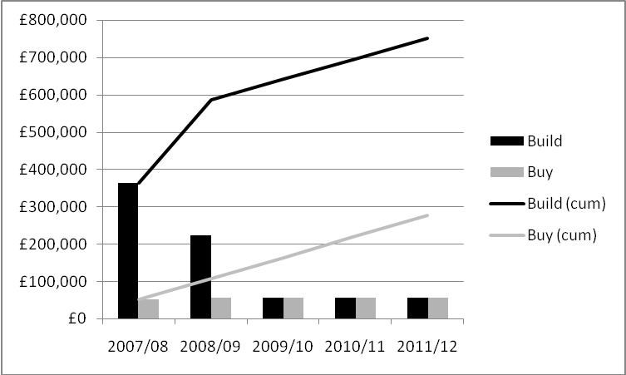

Next steps
- SMT acceptance of this recommendation
- Agree suitable Business Service to launch on BizTalk (Phase 2 Drop 3 options paper refers)
- Create project team and commence detailed planning and staff training
- Identify any potential re-use of hardware in Warwick

Introduction

Purpose of the Document
The purpose of this document is to recommend the adoption of Microsoft BizTalk Server 2006 R2 (BizTalk) as the business process orchestration and technical messaging engine for Exchange Services.

Exchange Services in Context
The Exchange is currently implementing a new Exweb enterprise architecture ("Exweb Portal" and "Exchange Services") covering both the business and technology domains, which involves a refresh of all core technology. This is being managed through the Strategic Exweb Transition Programme (SETP).
- The Exweb Portal will consist of all the presentation services to support the IFA using the Exweb website.
- Exchange Services will consist of all the business services, messaging hubs and data to support the delivery of our trading partners' products.
- Exchange Services will be built in a manner that allows the Exweb Portal, Exchange desktop products (Officeweb and Adviser Evolution) and any other third-party integrator (IFA system, Product Provider Extranet, Portal) to use them.

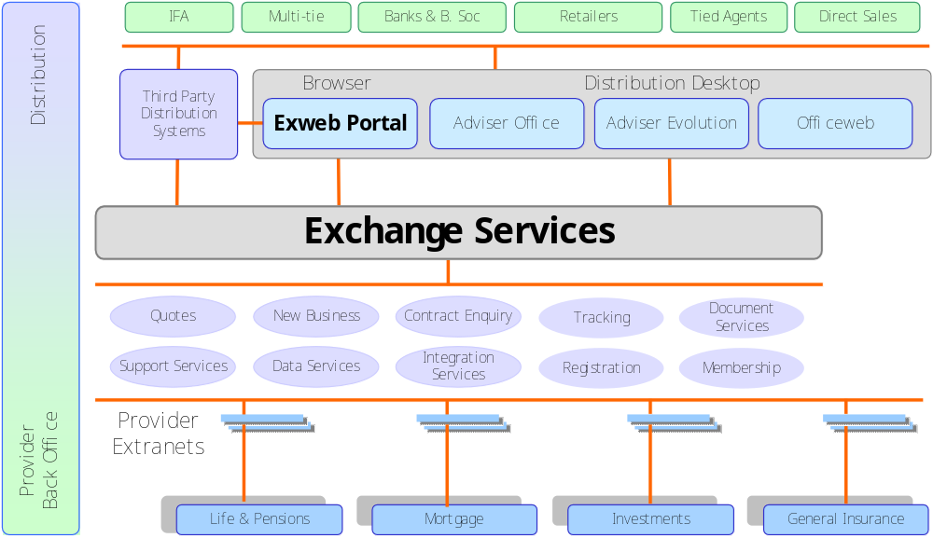

Scope of Exchange Services
- Message-based interfaces to all business services
- Message transformation to enable the support of different messaging standards
- Life & Pensions (L&P) quotes
- General Insurance (GI) associated quotes
- New Business submission
- Valuations processing
- Tracking data retrieval
- Provider and internal document retrieval
- Remote Publishing (2-Way) with Providers and Third Party Integrators (TPI)
- Cortex replacement
- B2B messaging framework
- Management information
- Support services e.g. splitting, filtering

Assumptions
- Specific BizTalk training for development and operational management will be given
- A full performance lab will be obligatory simulating a full set of providers
- Implementation will not involve further risk reduction by prototyping
- BizTalk will not be delivered standalone, but as an integral part of SETP phase 2 drop 3 scope

Why BizTalk?

What is BizTalk?
BizTalk is a business process management (BPM) server and is Microsoft's enterprise offering for the automation of business processes through the integration of diverse systems. BizTalk supports the integration of systems within one organisation, known as enterprise application integration (EAI), and of systems between many organisations, known as business-to-business (B2B) integration.
There are two main parts to BizTalk:
- A messaging component that provides the ability to communicate with a range of other software. By relying on pluggable adapters for different kinds of communication, the engine can support a variety of protocols and data formats, including HTTP, SOAP Web services and many others.
- Support for creating and running graphically-defined processes called orchestrations. Built on top of the BizTalk's messaging components, orchestrations implement the logic that drives all or part of a business process.
Other features include:
- Business Activity Monitoring (BAM), allows the monitoring of a running business process. The information is displayed in business rather than technical terms, and what gets displayed can be controlled directly by business people.
- A Business Rules Engine that allows evaluating complex sets of rules.
- Administration tools for configuring all aspects of BizTalk and applications hosted within it.
- A Health and Activity Tracking debugging tool that lets developers and administrators monitor and manage BizTalk and the orchestrations it runs.
BizTalk uses the latest releases of other Microsoft technologies. It is built on version 2.0 of the .NET Framework, its developer tools are hosted in Visual Studio 2005 and it uses SQL Server 2005 for storage. BizTalk can also run on 64-bit Windows, taking advantage of the larger memory and other benefits this new generation of hardware offers.
For more information see the Microsoft white paper – Understanding BizTalk Server 2006.

Previous Encounters

BizTalk Server 2000
This version was adopted by Assureweb as that portal's B2B communication hub. Although successfully implemented, only the messaging capability was used as the business orchestration and other features were too immature.

BizTalk Server 2002
An Exchange workshop with Microsoft consultants had the following results:
- It failed to get Origo messages to work in a high-performing scenario
- The level of business control over failed messages was insufficient
- The toolset to write translators was immature and unusable in complex scenarios (e.g. Exchange to Origo)

BizTalk Server 2004
This version was evaluated by the Marlborough Stirling CTO group. No recommendations were published.

Proof of Concept
Driven by its architecture principle 'Re-Use Before Buying, Buy Before Building' and the fact that in a technology refresh the amount of re-use would be limited, The Exchange undertook an investigation to establish the suitability and technical viability of Microsoft BizTalk Server 2006 R2 as the technology solution for Exchange Services, either as a whole or in part as shown in the diagram below i.e.
- Business Services, Support Services and Integration Services, or
- Business Services and Integration Services, or
- Support Services and Integration Services, or
- Integration Services, or
- A partial combination of the above e.g. only MI Events in Support Services
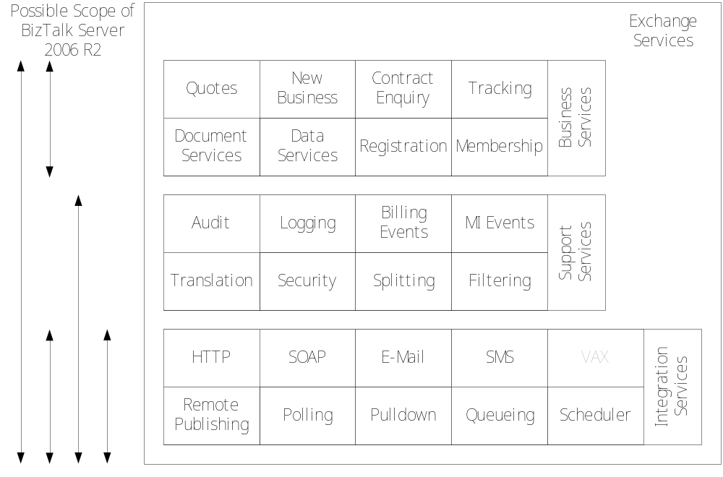
- BizTalk lab with Microsoft UK (30/7/2007 – 03/08/2007)
- Preparation included design days and collateral i.e. dummy provider capability, messages and schemas
- BizTalk Server 2006 was used for the proof of concept as it was the latest available production release.
- Developed term comparison transaction processing with multiple dummy providers
- Indicative performance tests exceeded requirements
- Business activity monitoring added with little effort
- Concluded that BizTalk was technically viable as the solution for Exchange Services

Benefits
The benefits of using BizTalk are:
- Supports bringing Exchange Services to market by the end of 2008
- Core Microsoft enterprise product with professional levels of support and published roadmap
- Fits with VFS Microsoft technology strategy
- Fits with the new Exchange enterprise architecture
- Decreased business risk by using supported software
- Easier to deploy in a new geographical location
- Delivers significant savings compared with the cost of a bespoke development
- Out of the box
  - Business activity monitoring
  - Adapters for current requirements i.e. HTTP, WCF, SQL, SOAP Web Services, SMTP
  - Adapters for future requirements i.e. SharePoint, FTP
  - Delivers significant message framework capability
- Architecture
  - Simpler platform i.e. one messaging hub, not many
  - Matches our server architecture approach
  - Logical upgrade path for Cortex
  - Can re-use existing up-to-date components
  - Can call own components
- Operations
  - Comprehensive operational management capabilities
  - Installation straightforward and well documented
  - Fits with the Exweb deployment model
  - Software updates are provided by the standard method (Windows Server Update Services)
  - Built-in instrumentation
- Performance
  - 64-bit capable with improved performance
  - Indicative performance good
  - Degrades gracefully
  - Scalable
  - High-performance
- Development
  - Comprehensive and intuitive toolset
  - Numerous customisation and extension points
  - Documentation fits our development process
  - Business process maps well to orchestration
  - Strict rules for messaging
  - Plug and play easy
  - Built-in debugging tools

Indicative Costs

External Consultancy
- 30 days non-Microsoft support @ £1,250 per day £37,500

External Training
- Assuming 3 developers and 2 operations staff
- 5 days BizTalk Server Comprehensive (£1,850) £9,250
- 2 days BizTalk Operations (£900) £1,800
- 2 days advanced XML (£900) £2,700

Hardware
Based on the indicative results from the BizTalk lab with Microsoft, each BizTalk environment would consist of:
- 2 application servers and 1 database server
- A duplicate set of hardware would be required in a warm Disaster Recovery site

Cost Assumptions
- Hardware is budgeted as part of the SETP programme
- New physical machines will be used for production environment (E50); there may be the potential for re-use of existing hardware
  - Application server - dual core, dual processor & 8Gb memory
  - Database server – quad core, dual processor & 32Gb memory
- Indicative IBM Hosting Costs based on last purchase for Alpha+ i.e. Dual Core, Quad Processor 8Gb memory. Note: quad core machines will not be available until Autumn this year
- IBM Hosting Costs based on 7 year write-off, no hardware refresh in 2008
- IBM Hosting Costs:
  - £7,798 OTC installation per server (no charge for DR duplicate)
  - £19,319 ASC per annum per server (no charge for DR duplicate)
- Virtual machines will be used for test environments
- 1 ESX server in Warwick or Cheltenham can accommodate 10 virtual images
- 3 Warwick based test environments – E30, E40 & E45 totalling 9 virtual machines = 1 ESX server
- 2 Cheltenham based test environments – E10 & E20 totalling 6 virtual machines = 1 ESX Server
- BTS Cheltenham Costs (OTC): ESX server (£22,000) - Exchange drawing a 50% charge (£11,000)
- Assuming 20% BTS Cheltenham support costs

Hardware Cost Summary
 | FY 2008/2009 |  | Subsequent Years
Environment | OTC | ASC | OTC | ASC
Production (E50) | £23,394 | £57,957 | £0 | £57,957
Test (E30, E40 & E45) | £7,798 | £19,319 | £0 | £19,319
Test (E10 & E20) | £11,000 | £2,200 | £0 | £2,200
Totals | £42,192 | £79,476 | £0 | £79,476

Software Licences

Licences Required
Environment | Licence Type | Number
Production (E50) – Site A | Windows Server 2003 R2 Enterprise Edition Authenticated | 6
 | BizTalk Server 2006 R2 Enterprise Edition | 4
 | SQL Server 2005 Enterprise Edition | 2
Production (E50) – Site B (DR) | Not required for dormant site | 0
Test (E10, E20, E30, E40 & E45) | Windows Server 2003 R2 Enterprise Edition | 3 per environment
 | BizTalk Server 2006 R2 Enterprise Edition | 2 per environment
 | SQL Server 2005 Enterprise Edition | 1 per environment
Development | BizTalk Server 2006 R2 Developer Edition | 1 per workstation  1 per build machine

Cost Assumptions
- Service Providers Licensing Agreement (SPLA) Windows Server 2003 R2 Enterprise Edition Authenticated - £130.49 per processor per month
- SPLA BizTalk Server 2006 R2 Enterprise Edition - £693.17 per processor per month
- SPLA SQL Server 2005 Enterprise Edition - £561.20 per processor per month
- SPLA test licences (E30, E40 & E45) require reporting but incur no charge
- BizTalk Server 2006 R2 Enterprise Edition (E10 & E20) - no charge as sourced from Partner allocation
- BizTalk Server 2006 R2 Developer Edition - no charge as covered by MSDN subscriptions

Licence Cost Summary
 | FY 2008/2009 |  | Subsequent Years
Environment | OTC | ASC | OTC | ASC
Production (E50) | £0 | £56,136 ¹ | £0 | £56,136
Test (E30, E40 & E45) | £0 | £0 | £0 | £0
Test (E10 & E20) | £0 | £0 | £0 | £0
Development | £0 | £0 | £0 | £0
Totals | £0 | £56,136 | £0 | £56,136
¹ Windows Server 2003 R2 Enterprise Edition Authenticated – 6 * (130.49 * 12) = £9,395
BizTalk Server 2006 R2 Enterprise Edition – 4 * (693.17 * 12) = £33,272
SQL Server 2005 Enterprise Edition – 2 * (561.20 * 12) = £13,469

Comparative Costs – Build vs Buy

Build Estimates
These are ballpark estimates of the effort required to build the essential functionality that comes with BizTalk i.e. just the plumbing. The installation and implementation profile would be similar.
Item | Effort (man days) | Cost (£260 per day)
Messaging Framework (Cortex replacement) | 1,440 | £374,400
Messaging Adapter – HTTP | 60 | £15,600
Messaging Adapter – SOAP | 80 | £20,800
Messaging Adapter – SQL | 40 | £10,400
Messaging Adapter – WCF | 80 | £20,800
Messaging Adapter – FILE | 40 | £10,400
Messaging Adapter – FTP | 40 | £10,400
Messaging Adapter – SMTP | 40 | £10,400
Application Management Toolset | 80 | £20,800
Configuration Management Toolset | 80 | £20,800
Operational Management Toolset | 80 | £20,800
Performance Tuning | 40 | £10,400
Totals | 2,100 | £546,000

Assumptions
- Hardware profile would be the same
- Build would start in October 2007 and need to be complete by the end of June 2008 to allow time to deploy the first business service by the end of 2008
- 10% ongoing maintenance cost for build
- ⅔ build cost in financial year 2007/2008 ¹
- ⅓ build cost in financial year 2008/2009 ²
- ¾ build maintenance cost @10% in financial year 2008/2009 ²
- BizTalk consultancy and training in financial year 2007/2008 ³

Breakdown by Year
Financial Year | Build | Buy | Build (cumulative) | Buy (cumulative)
2007/2008 | £364,000¹ | £51,250³ | £364,000 | £51,250
2008/2009 | £222,950² | £56,136 | £586,950 | £107,386
2009/2010 | £54,600 | £56,136 | £641,550 | £163,522
2010/2011 | £54,600 | £56,136 | £696,150 | £219,658
2011/2012 | £54,600 | £56,136 | £750,750 | £275,794

Build vs Buy Graph

Next Steps
- SMT acceptance of this recommendation
- Agree suitable Business Service to launch on BizTalk (Phase 2 Drop 3 options paper refers)
- Create project team and commence detailed planning and staff training
- Identify any potential re-use of hardware in Warwick

